Functional Specification: Store Commerce POS

1. Executive Summary
This document provides a comprehensive overview of the Store Commerce POS dashboard. It details the operational workflows for shift management, inventory tracking, and system configuration to ensure seamless retail operations.

Global Navigation Sidebar
The sidebar provides persistent access to the core modules of the Store Commerce POS. It allows users to switch between operational, inventory, and sales views efficiently.
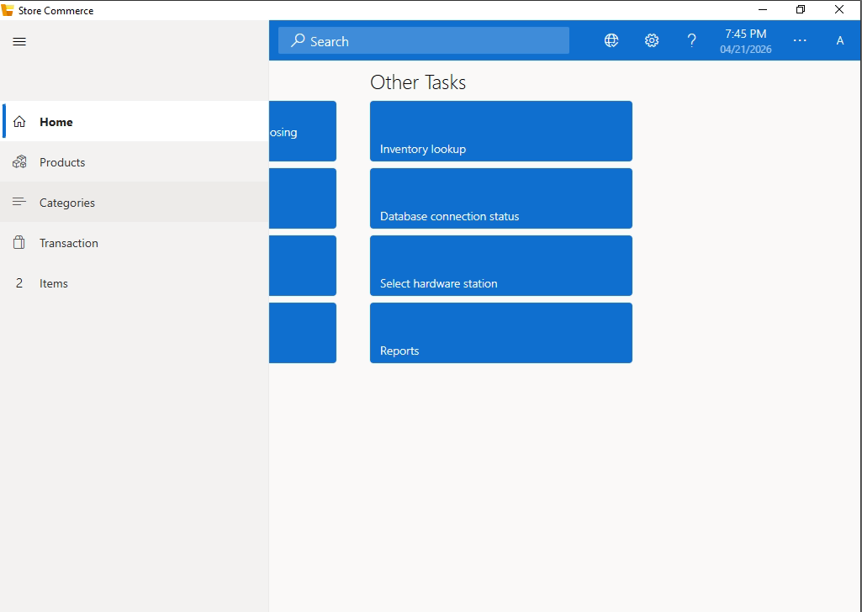
Figure: Navigation Sidebar Components

Navigation Controls Detail:
- Home: Navigates back to the main dashboard where "Shift Tasks" and "Other Tasks" are located.
- Products: Provides a comprehensive list of all items available in the store database, including pricing and SKU details.
- Categories: Allows users to browse products filtered by specific groups (e.g., Electronics, Apparel, Grocery) for faster selection.
- Transaction: Opens the active sales terminal where items are scanned, discounts are applied, and payments are processed.
- Items (Indicator): Displays the current count of items added to the pending transaction or specific sub-lists.

2. System Interface Overview
The dashboard is designed with a user-centric grid layout, categorized into operational "Shift Tasks" and administrative "Other Tasks."
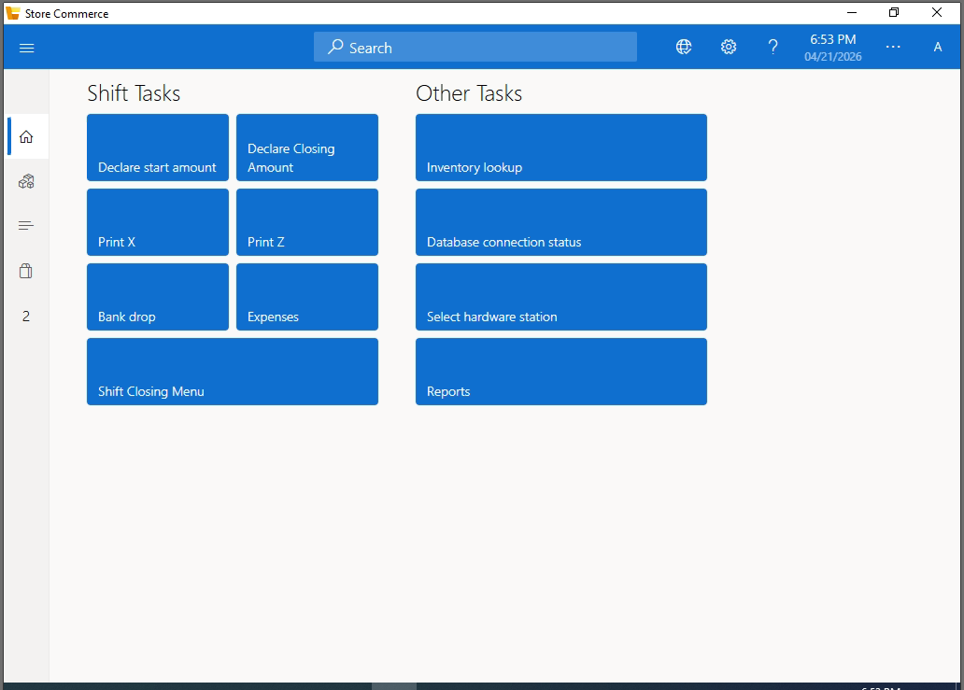
Figure 1: Main Dashboard Interface
3. Functional Analysis: Shift Tasks
This module manages the daily lifecycle of a point-of-sale terminal, from opening the float to final reconciliation.

Feature | Functional Description
Declare Start Amount | Used to record the initial cash float in the drawer at the beginning of a shift.
Declare Closing Amount | Facilitates the end-of-day cash count to reconcile physical cash with system sales.
Print X | Generates a mid-shift summary report without resetting the register totals.
Print Z | Executes the final shift closure and prints a non-reversible terminal report.
Bank Drop | Records the transfer of excess cash from the drawer to a secure vault or bank.
Expenses | Logs miscellaneous store expenditures paid directly from the cash drawer.
Shift Closing Menu | A centralized hub to finalize all pending transactions and terminate the current session.

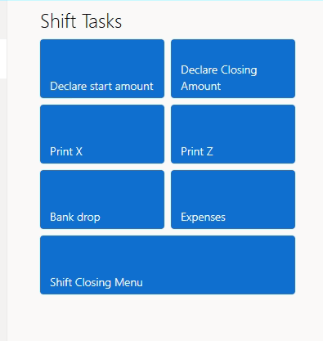
Figure 2: Shift Management Controls

- Function: Declare Starting Amount
This is the mandatory first step in the daily retail workflow. It allows the operator to input the initial cash float available in the drawer.
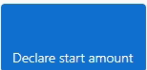
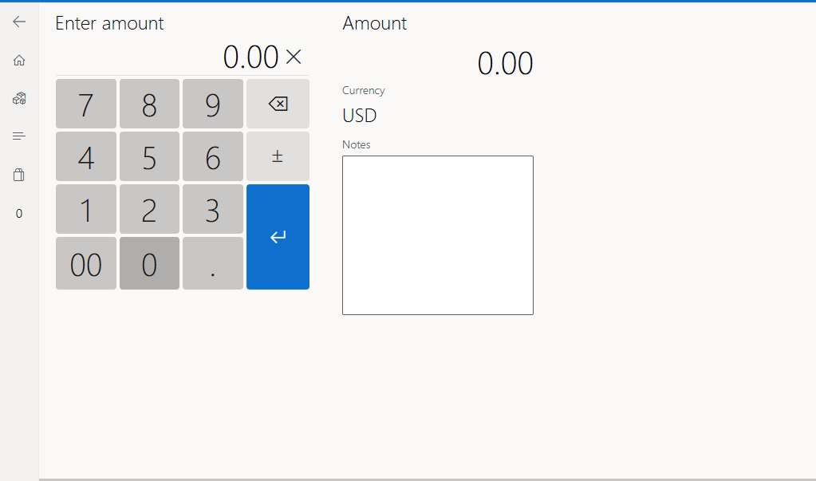
Functional Components:

- Touch-Optimized Keypad: A large, accessible numeric keypad designed for high-speed data entry.
  - Specific Keys: Includes a 00 key for faster rounded entries and a . (decimal) for fractional currency.
  - Clear/Backbox: Allows for real-time correction of entry errors.
- Currency & Amount Display:
  - Primary Display: Shows the real-time numeric input.
  - Currency Label: Fixed to the local operational currency (e.g., USD).
- Operational Notes Field:
  - A dedicated text area for the operator to record specific details (e.g., "Partial coins," "Supervisor approved opening").
- Submission Control (Enter Button):
  - The blue 'Enter' arrow commits the entry and transitions the system state to 'Open,' enabling the Transaction module.

- Function: Declare Closing Amount
This interface is utilized at the end of a business shift to perform a "Tender Declaration." The operator must count and record the final cash remaining in the drawer to reconcile against system-recorded sales.

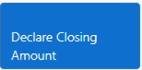
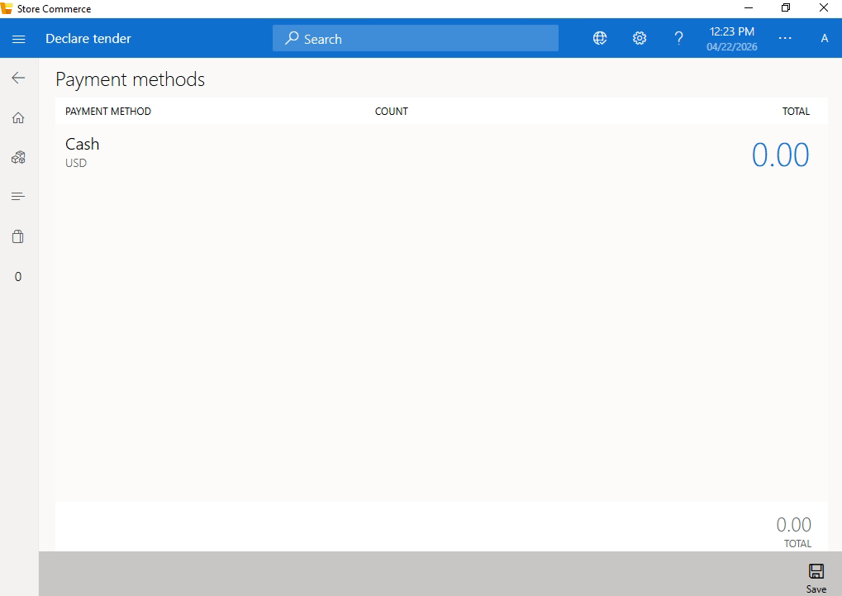

- Payment Methods List:
  - Displays all accepted tender types (e.g., Cash, Credit Card, Gift Card).
  - Currency: Locked to the operational currency (e.g., USD).
- Count & Total Fields:
  - Count: Allows the user to enter the number of individual units (e.g., total number of bills).
  - Total: The system automatically calculates or allows direct entry of the final sum for each payment method.
- Global Total:
  - Displayed at the bottom right, showing the aggregate value of all declared tenders.
- Footer Actions (Save Button):
  - Save: Commits the final count to the database. Once saved, the system compares this against the "Expected Amount" to calculate any overages or shortages.

Mid-Shift Reporting (Print X)
The Print X function is a critical audit tool used to generate a real-time snapshot of the terminal's financial activity without terminating the active shift.

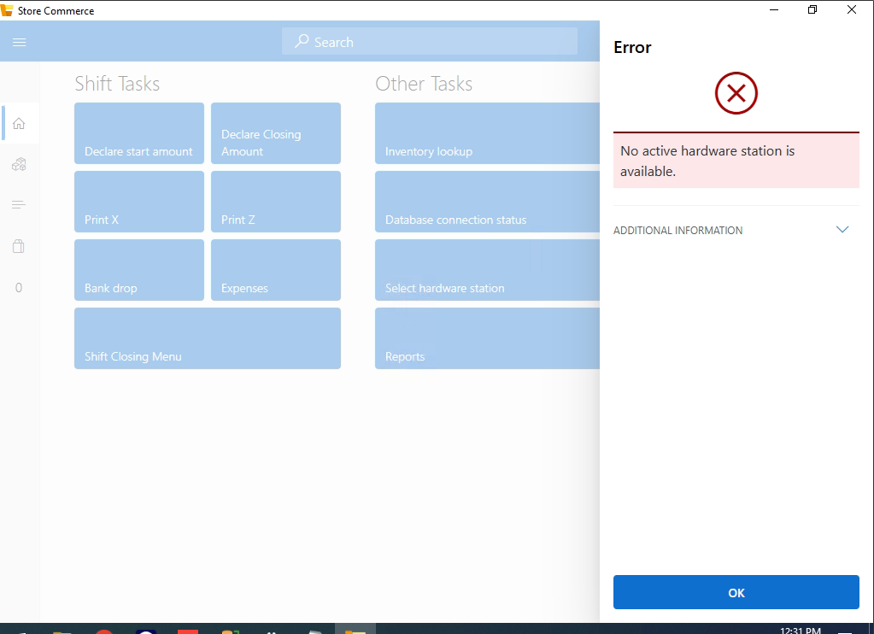

1. Functional Overview
- Purpose: To provide a mid-day reconciliation report for supervisors to verify cash-on-hand against system sales.
- Non-Destructive Action: Unlike the 'Print Z' report, executing a 'Print X' does not reset the transaction counters or clear the local database shift totals.
2. Technical Specifications & Data Points
When this button is triggered, the system must aggregate and print the following data:

Report Section | Data Requirement
Shift Metadata | Terminal ID, Staff Name, Shift Start Time, and Current Timestamp.
Gross Sales | Total value of all completed transactions since the 'Declare Start Amount'.
Tender Breakdown | Categorized totals for Cash, Credit Card, and Gift Card payments.
Operational Adjustments | Total value of Voids, Returns, and Discounts applied.
Cash Logistics | Initial Float (Start Amount) + Net Cash Sales - Bank Drops.
Financial Shift Closure (Print Z)

The Print Z function is the final mandatory operation for terminating a business shift. Unlike the 'Print X' report, this action is final and destructive, meaning it resets the registers for the next business cycle.


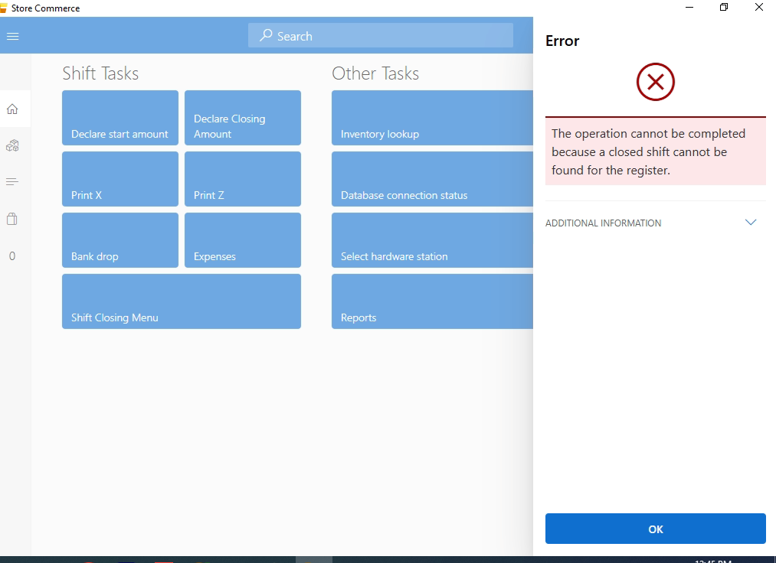
- Purpose: To finalize all sales data, settle financial totals, and officially close the terminal’s active shift.
- State Change: Executing a 'Print Z' clears the current shift’s accumulators and resets the "Net Sales" counter to zero.
- Legal Requirement: This report serves as the primary document for daily fiscal reconciliation and tax reporting.
Data Segment | Technical Requirement
Final Reconciliation | Total starting float + total net sales - total bank drops.
Tender Settlement | Final totals for Cash, Credit Card, and Gift Card payments.
Overage/Shortage | The calculated difference between "Expected Cash" and "Declared Closing Amount."
Transaction Audit | A count of total receipts issued, total voids performed, and total returns processed.
Shift Duration | Precise logging of the "Declare Start Amount" time vs. the "Print Z" timestamp.

Cash Logistics (Bank Drop)
The Bank Drop function (also known as a "Safe Drop") is an operational security protocol used to transfer surplus cash from the POS terminal to a secure back-office safe or bank deposit during an active shift.
1. Interface: Tender Removal (Bank Drop)
This screen allows the operator to specify the exact amount of currency being removed from the drawer.
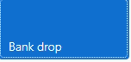
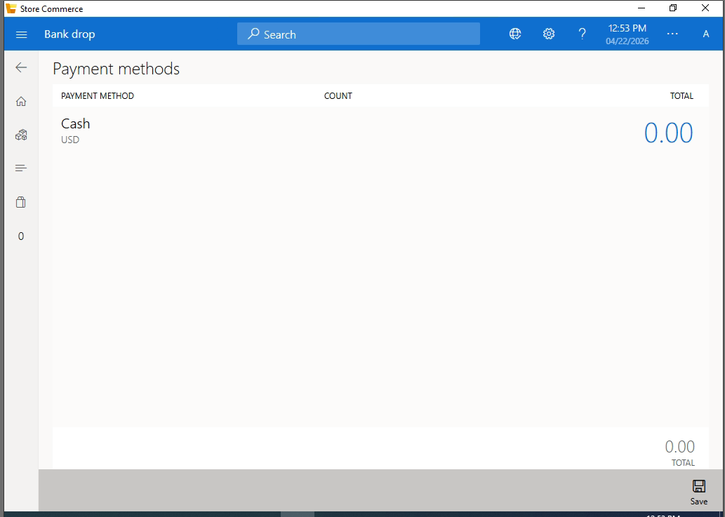
- Payment Method Selection:
  - Primarily utilized for Cash (USD), as physical currency is the most common asset transferred during a drop.
- Count & Total Input:
  - Count: The operator can record the quantity of specific denominations being removed.
  - Total: Displays the calculated monetary value of the drop for that specific tender.
- Footer Controls (Save Button):
  - Save: Commits the drop record to the database. This action immediately reduces the "Expected Cash" balance in the drawer for the current shift.

Operational Expenditures (Expenses)
The Expenses module facilitates the recording and tracking of miscellaneous petty cash outflows directly from the POS terminal. This ensures that every deduction from the cash drawer is accounted for in the final shift reconciliation.

- Interface: Expense Accounts Selection
This screen presents a categorized list of approved expense accounts to ensure standardized financial reporting.

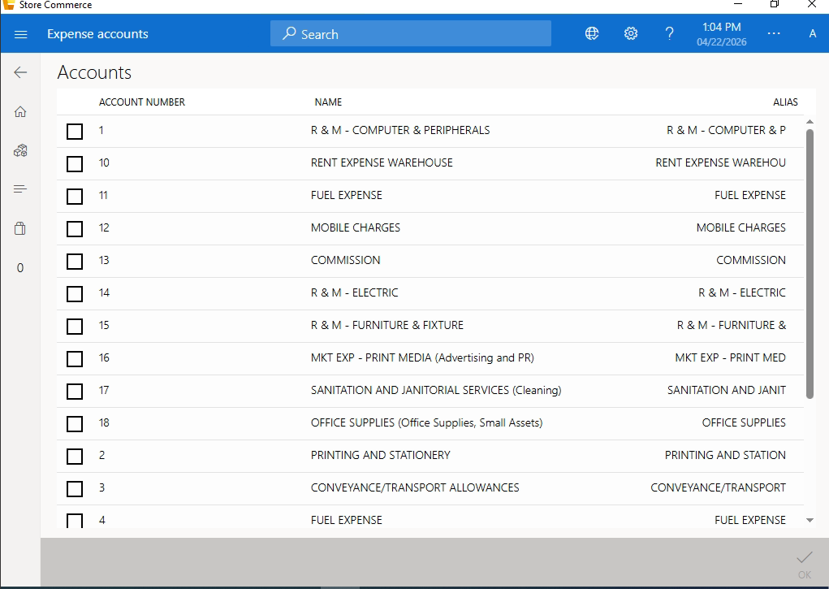
- Account Ledger List:
  - A comprehensive grid displaying Account Number, Account Name, and Alias.
  - Standard Categories Include: * R & M (Computer, Electric, Furniture).
    - Operational Costs (Fuel, Rent, Mobile Charges).
    - Administrative Costs (Printing, Office Supplies, Cleaning).
    - Marketing and Commissions.
- Selection Mechanism:
  - Checkbox-based selection allows the operator to map the expense to the correct financial category.
- Validation Control:
  - The 'OK' confirmation button (bottom right) commits the selection and transitions the user to the amount entry screen.

Shift Termination (Shift Closing Menu)
The Shift Closing Menu is the final administrative layer of the daily retail cycle. It acts as a gateway to ensure all mandatory end-of-shift tasks have been validated before the terminal session is terminated.
1. Interface: Close Shift Navigation
Once all financial declarations (Tender and Expenses) are completed, the user accesses this sub-menu to finalize the process.

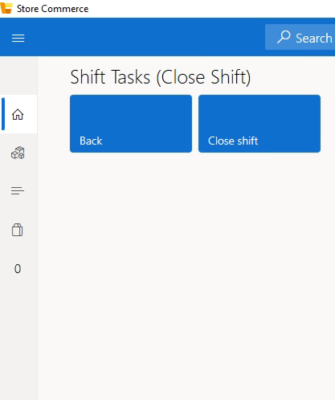
- Back Button: Returns the user to the main Shift Tasks dashboard if further adjustments are required.
- Close Shift Button: The final execution command. Triggering this button performs a system-wide check to ensure a Print Z has been generated and all transaction data is synced.

Shift Finalization & System Logout Procedures
1. End-of-Shift Reconciliation
The closing process begins with a formal declaration of all funds remaining in the terminal to ensure financial accountability.
- Declare Closing Amount: This mandatory step requires the operator to perform a physical count of all tender types (Cash, Credit Cards, etc.) before the shift can be terminated.
- Tender Counting Interface: A dedicated grid where the user enters the "Count" or "Total" for each payment method.
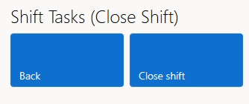
2. Shift Termination (The Closing Menu)
Once the financial amounts are saved, the user must navigate to the final termination menu to release the register session.
- Execution Command: The user selects the "Close shift" button to trigger the final database update and reset the terminal.
- Exit Protocol: Choosing this action confirms that all business for the current session is complete and prepares the terminal for the next operator.

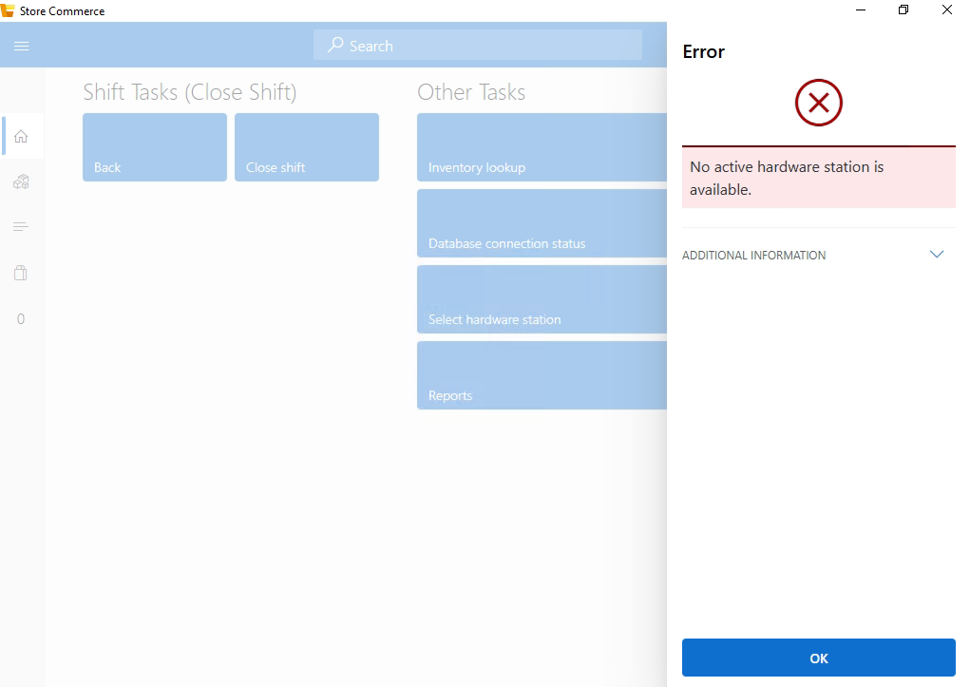
3. Post-Closure Validation & Re-Entry
After the shift is successfully closed, the system secures itself by returning to the primary entry point.
- System Logout: Upon completion of the close-shift logic, the application automatically redirects to the Sign-in screen.
- Shift Status Verification: If a user logs back in after a successful closure, the system recognizes the inactive state of the register and prompts the user to open a new session.
- New Shift Initialization: The sidebar menu will display the "Open a new shift" option, indicating that the previous cycle was correctly finalized.
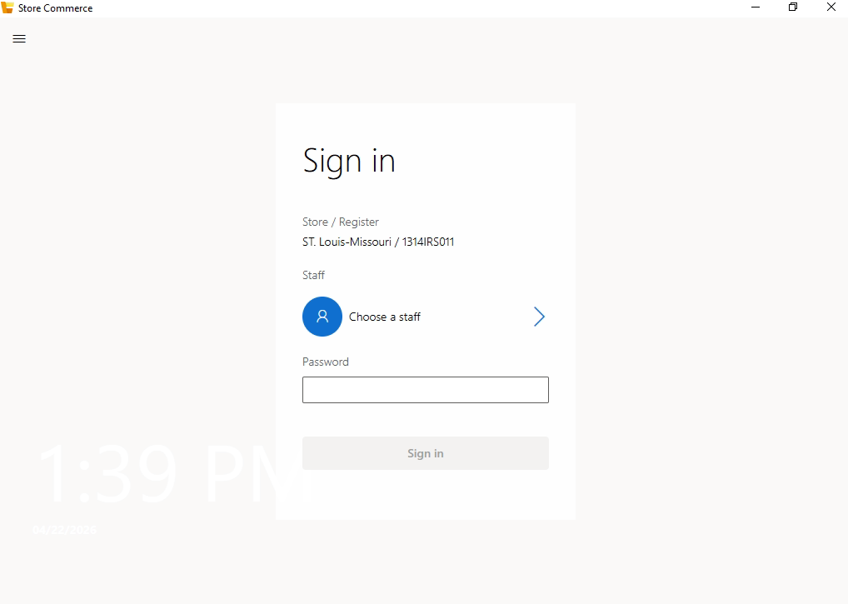

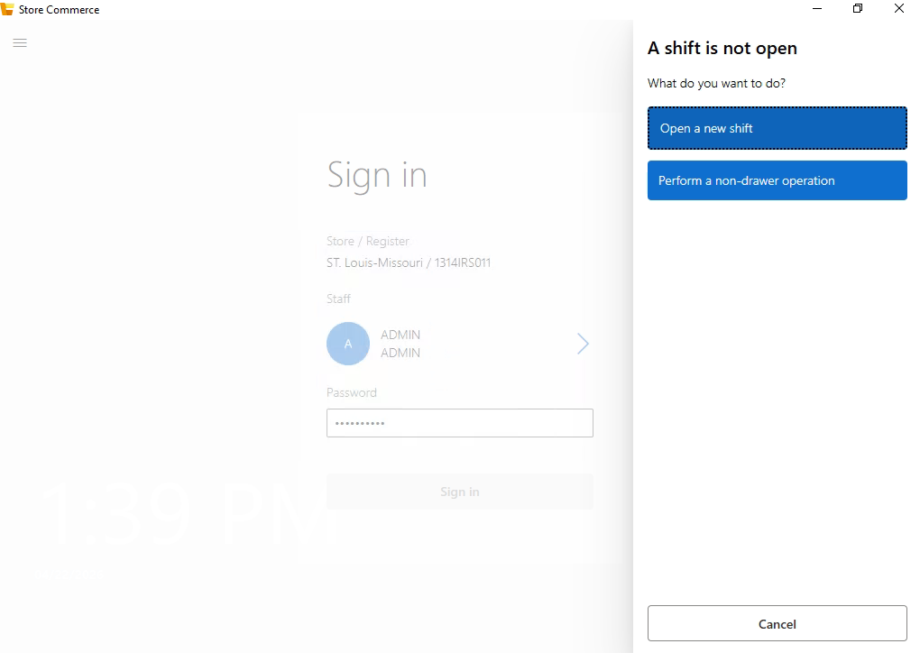

4. Functional Analysis: Other Tasks
This section handles backend operations, hardware integration, and data reporting.

Feature | Functional Description
Inventory Lookup | Provides real-time access to stock levels across different product categories.
Database Connection Status | Monitors the live sync between the local POS terminal and the central server.
Select Hardware Station | Allows the user to configure printers, scanners, and external display units.
Reports | Accesses detailed analytical data, including sales trends, tax summaries, and auditor logs.

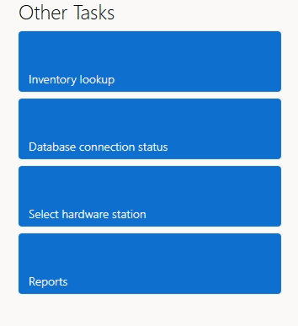
Figure 3: Administrative and Inventory Tools
Other Tasks – Inventory Lookup
The Inventory Lookup module serves as a real-time informational gateway, allowing terminal operators to query the central product database for stock availability, pricing, and item specifications.
1. Interface: Product Search & Discovery
This interface is optimized for high-speed inquiries using multiple search parameters.
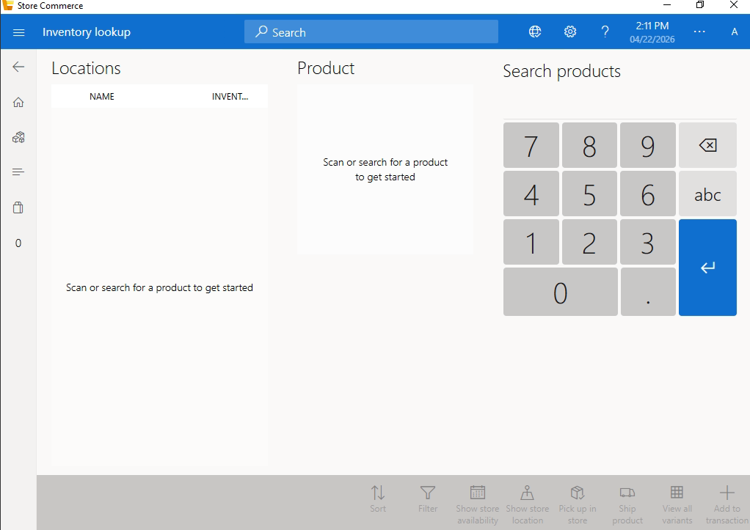

- Search Parameters: Operators can locate items via Product Name, Item ID, or Barcode Scan using the top-mounted search bar.
- Inventory Grid View: A comprehensive list displaying the following metadata for each SKU:
  - Item ID: The unique alphanumeric identifier for the product.
  - Product Name: Detailed nomenclature (e.g., "BOYS INNER SUIT MTM").
  - Pricing: Displays the current active retail price.
  - Unit of Measure (UOM): Categorized as "Pcs" (Pieces) or other relevant units.

Other Tasks – Database Connection Status
The Database Connection Status module is a critical diagnostic tool used to monitor the real-time synchronization between the local POS terminal and the central Retail Server. It ensures data integrity and provides manual controls for offline operations.

1. Interface: Synchronization Overview
This dashboard provides a high-level summary of the terminal's current connectivity and data health.

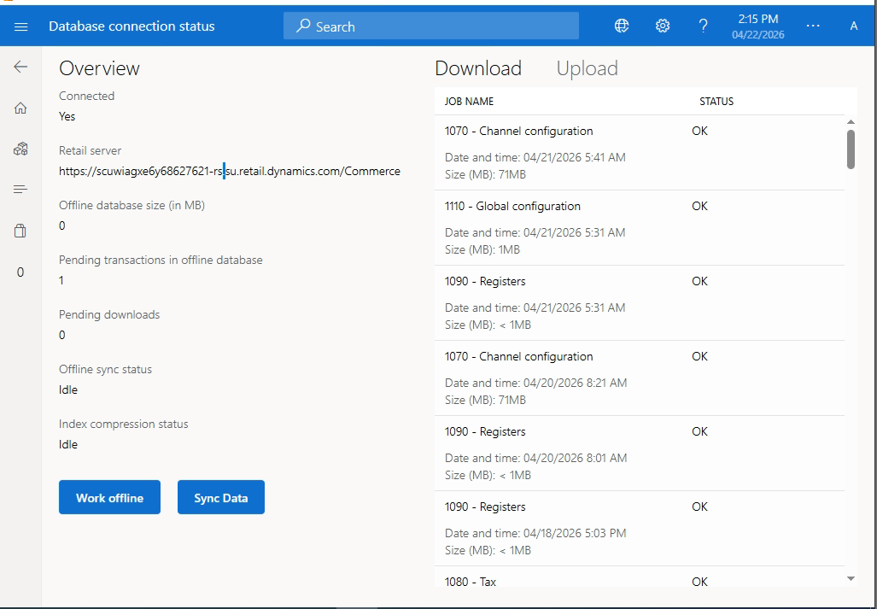
Key Information Fields:
- Connection Status: A binary indicator (e.g., "Connected: Yes") confirming if the terminal is actively communicating with the cloud-based Retail Server.
- Retail Server URL: Displays the specific endpoint address (e.g., https://scuwiagxe6y68627621-rs.su.retail.dynamics.com/Commerce) to which the terminal is linked.
- Pending Transactions: Shows the count of local transactions stored in the offline database that have not yet been uploaded to the central server.
- Sync Status: Monitors active background processes such as "Offline sync status" and "Index compression status," typically shown as "Idle" when no tasks are running.

Other Tasks – Reports
The Reports module provides the terminal operator with access to localized financial and operational data, allowing for immediate review of sales performance and transaction history directly from the POS interface.
1. Interface: Reports Dashboard
The reporting landing page categorizes various data sets to help users locate specific information quickly.


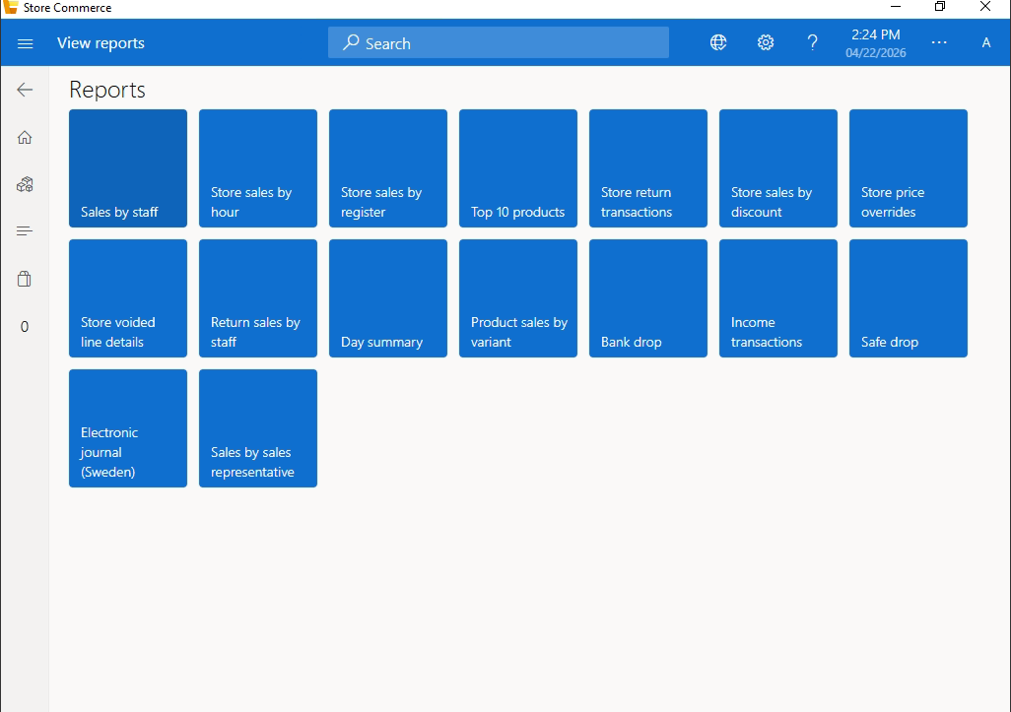

Functional Components:
- Store Reports:
  - Store Sales: Summarizes total revenue generated by the current location across all registers.
  - Store Sales by Register: Breaks down sales performance per specific POS terminal.
- Staff Performance:
  - Store Sales by Staff: Tracks revenue generated by individual employees, useful for performance audits or commission tracking.
- Shift Reports:
  - Shift Reports: Provides a historical log of closed shifts, allowing managers to review previous "Print Z" data.
- Inventory Reports:
  - Price Check: A dedicated report for verifying current pricing updates across the catalog.

Module: Store Sales by Staff – Report Configuration
The Store Sales by Staff module allows management to generate performance reports filtered by specific personnel and timeframes. This ensures accurate tracking of staff productivity and sales accountability.
1. Interface: Report Filtering & Parameters
Before the report is generated, the system requires the operator to define specific parameters to narrow down the data.


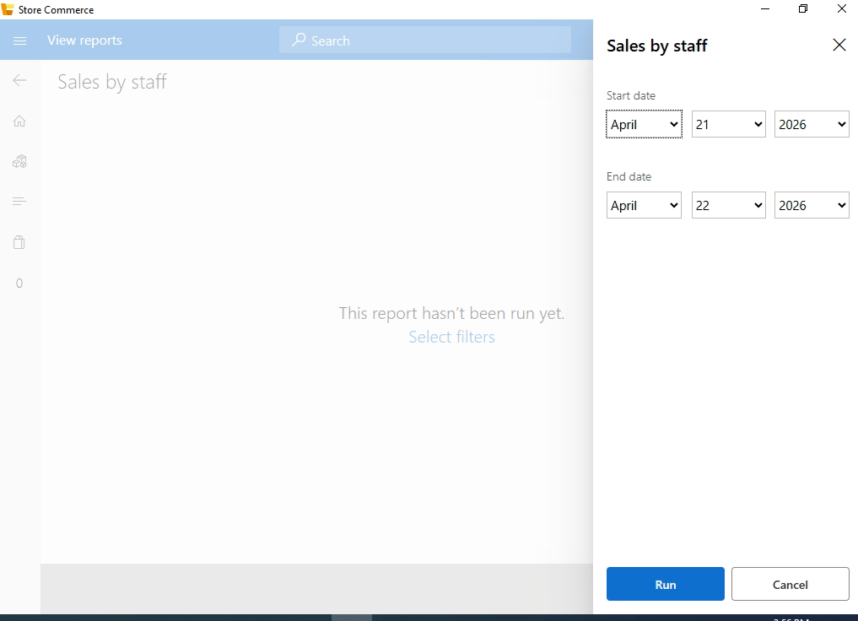
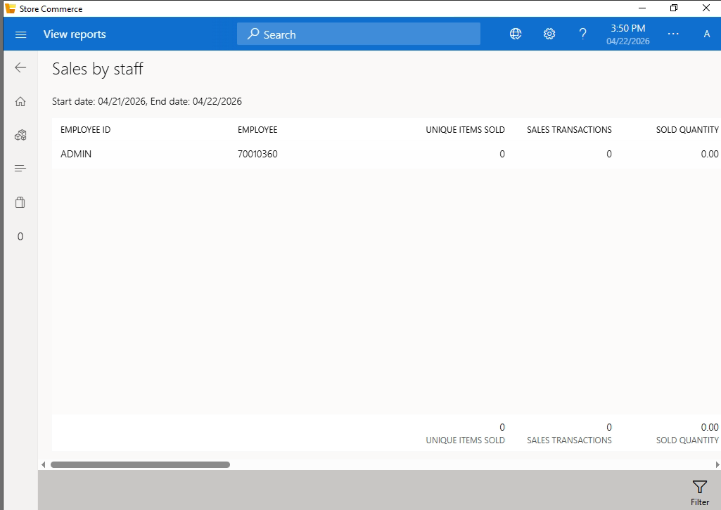
Staff Member Selection:
- Function: A dropdown or search menu where the operator selects a specific employee (e.g., "000161 - Store Manager").
- Logic: The system queries the staff database to populate this list with active employee IDs and their respective names.
Date Range Selection:
- Start Date / End Date: Users define the specific window for the audit (e.g., 4/22/2026).

Module: Store Sales by Hour – Analytical Reporting
The Store Sales by Hour report provides a chronological breakdown of sales transactions throughout the business day. This data helps management identify "peak hours" versus "slow periods" to better manage floor staff and inventory replenishment.

1. Interface: Parameter Configuration
Before generating the hourly analysis, the user must define the specific date for the report.
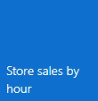
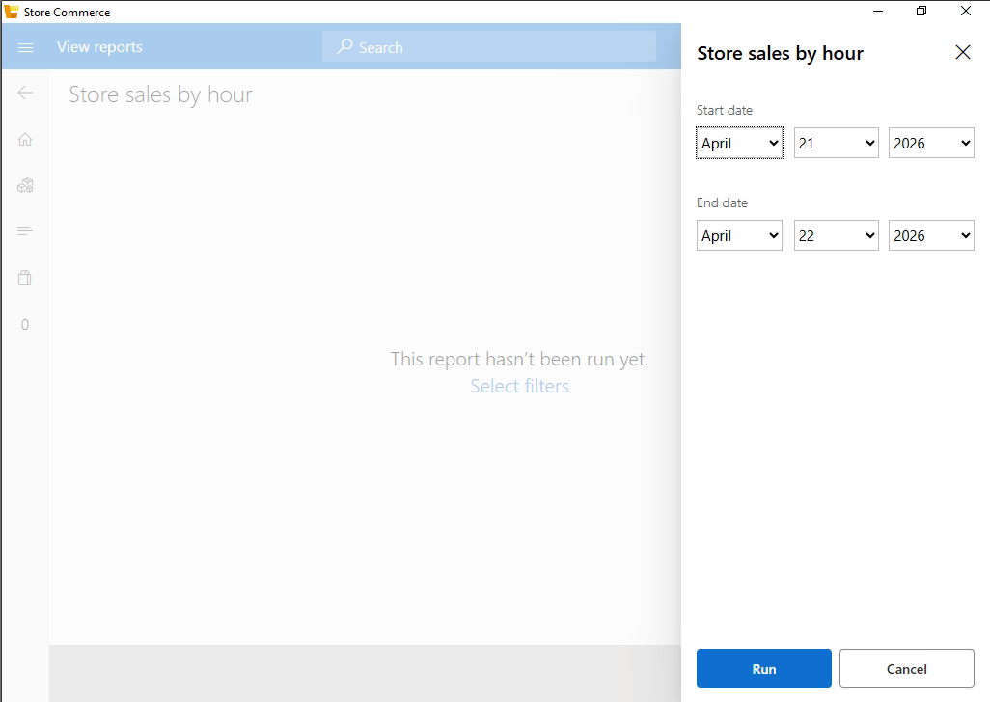
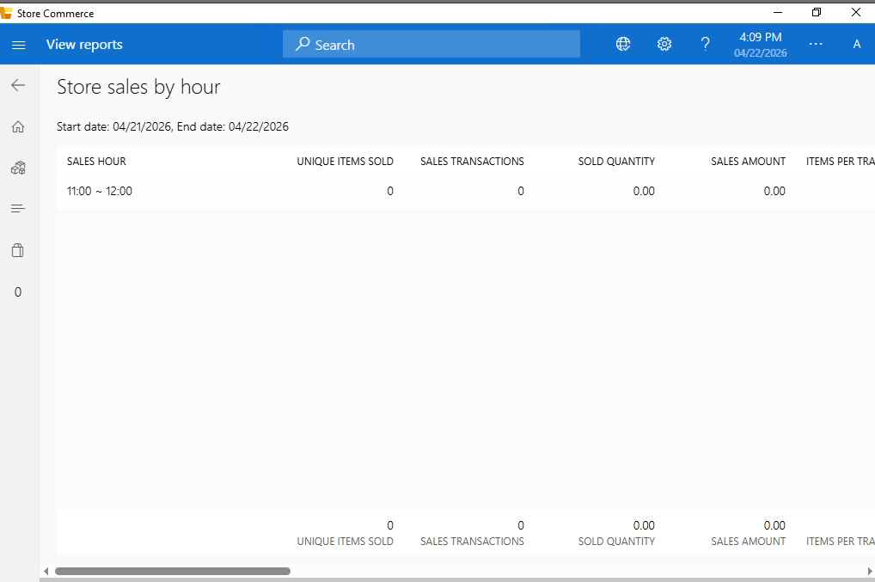

Module: Store Sales by Register – Terminal Analytics
The Store Sales by Register report allows management to isolate financial data for a specific POS terminal. This is particularly useful in multi-terminal environments to identify high-performing stations or to investigate cash discrepancies at a particular register.
1. Interface: Register Selection & Parameters
To generate this report, the user must specify both the register and the time period for analysis.
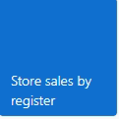
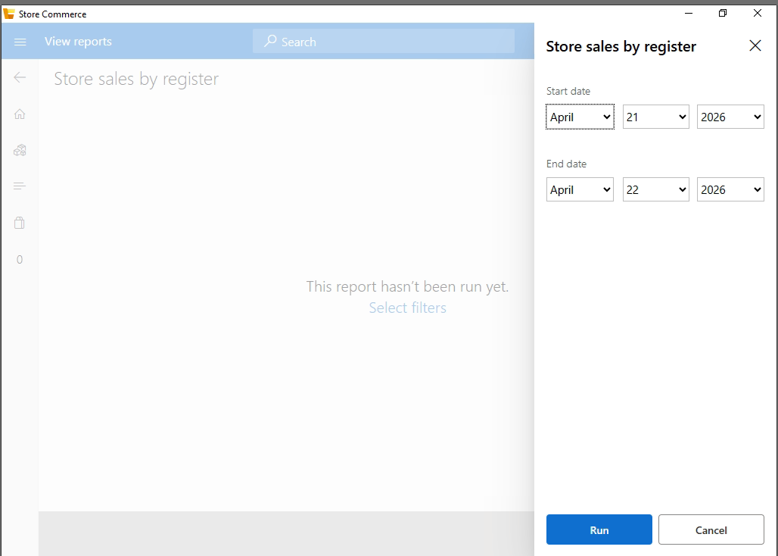
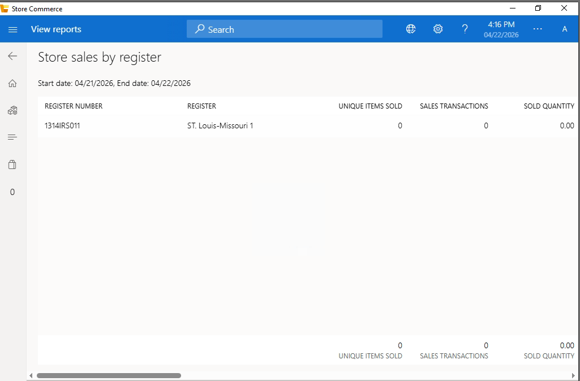
Register Selection:
- Function: A dropdown menu where the operator selects the specific terminal ID (e.g., "M-POS-01").
- Logic: The system retrieves a list of all active registers registered to the current store location.
Date Range Selection:
- Start/End Date: Defines the duration for the sales audit.
Navigation Controls:
- Back Button: Cancels the request and returns to the Reports dashboard.

Module: Top 10 Products – Sales Performance Analysis
The Top 10 Products report identifies the highest-performing stock-keeping units (SKUs) based on sales volume and revenue. This enables management to understand consumer trends and ensure that high-demand items are always sufficiently stocked.

1. Interface: Report Parameters
Before generating the rankings, the user must define the temporal scope of the data.

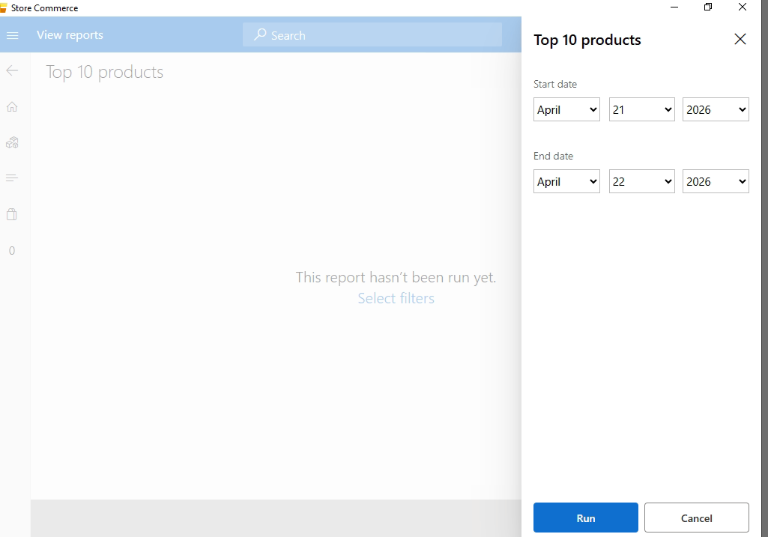
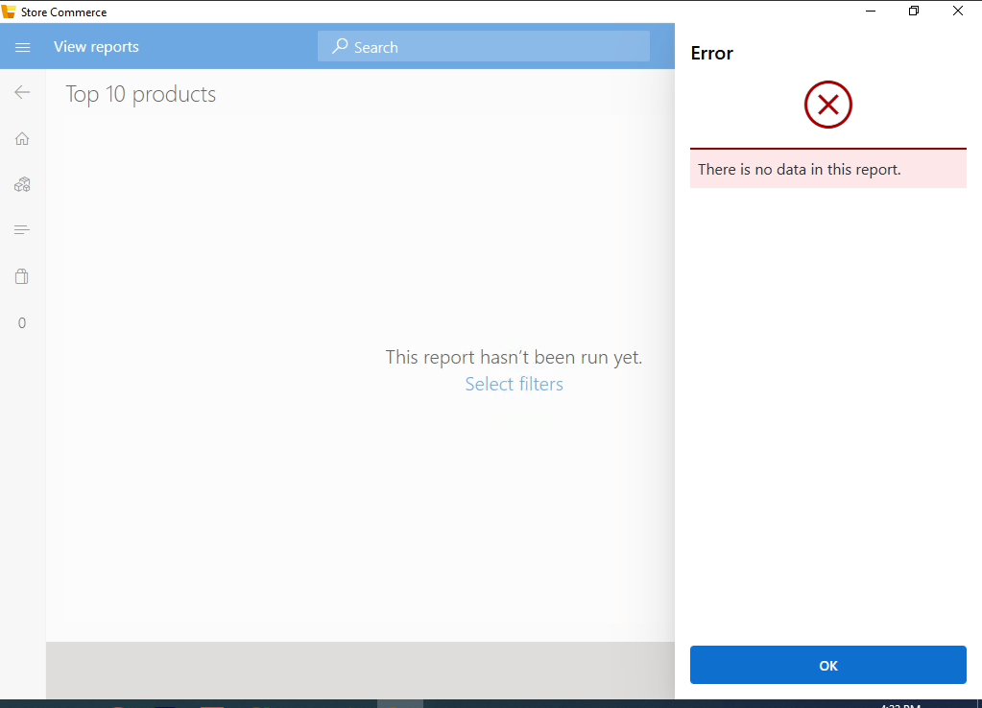
Date Range Selection:
- Start Date / End Date: Users define the specific period for analysis (e.g., a daily, weekly, or monthly audit).
- System Behavior: The report aggregates all transactions within these dates to calculate the ranking.
Navigation Controls:
- Back Button: Returns the user to the Reports selection dashboard.

Module: Store Return Transactions
The Store Return Transactions report is a specialized audit tool that allows management to track all product returns within a specific timeframe. It provides transparency into why items are being returned and ensures that refund totals are accurately reconciled against the store's daily revenue.

1. Interface: Return Query & Parameters
To view a history of returns, the operator must define the search criteria to filter the transaction database.
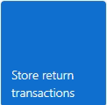
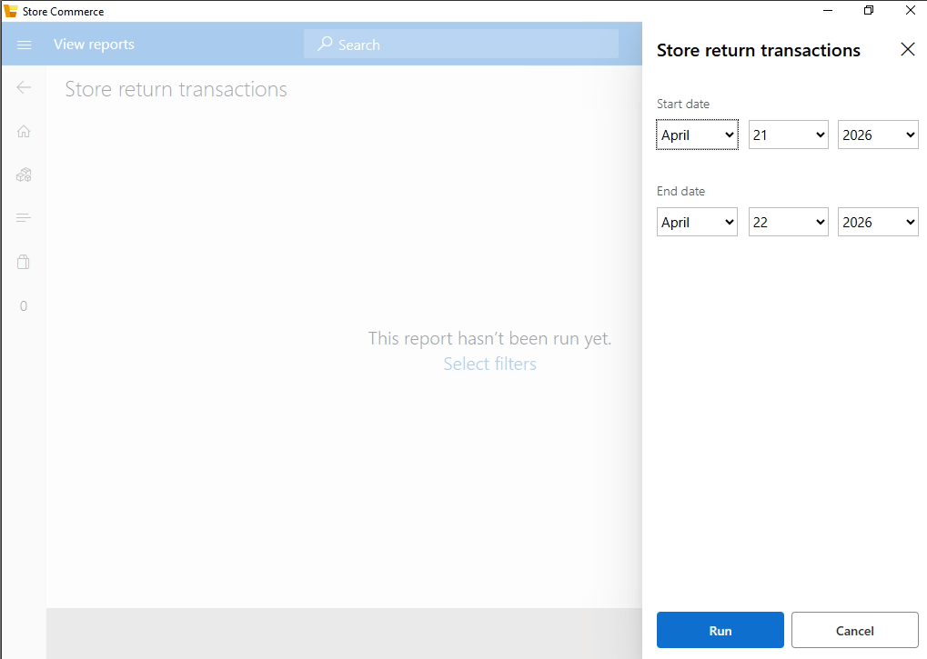
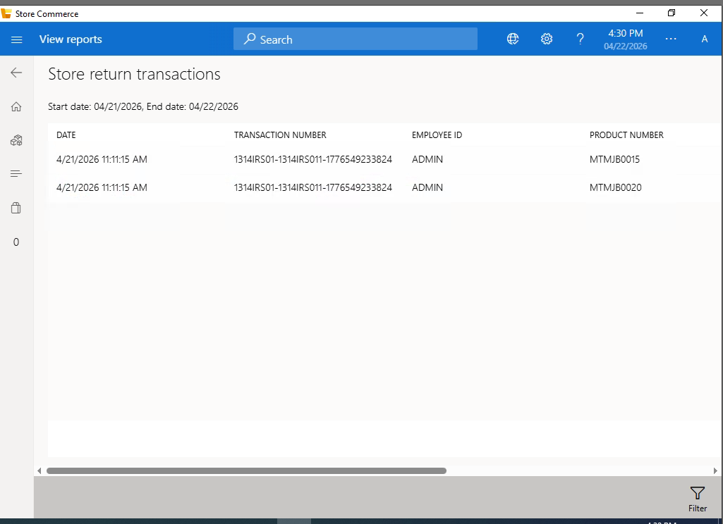
Register Selection:
- Function: Filters the results to show returns processed on a specific terminal (e.g., "1314IRS011").
Date Range Selection:
- Start Date / End Date: Users select the period they wish to audit.
- Operational Note: This is often used during end-of-day closing to verify that the physical return slips match the digital system records.


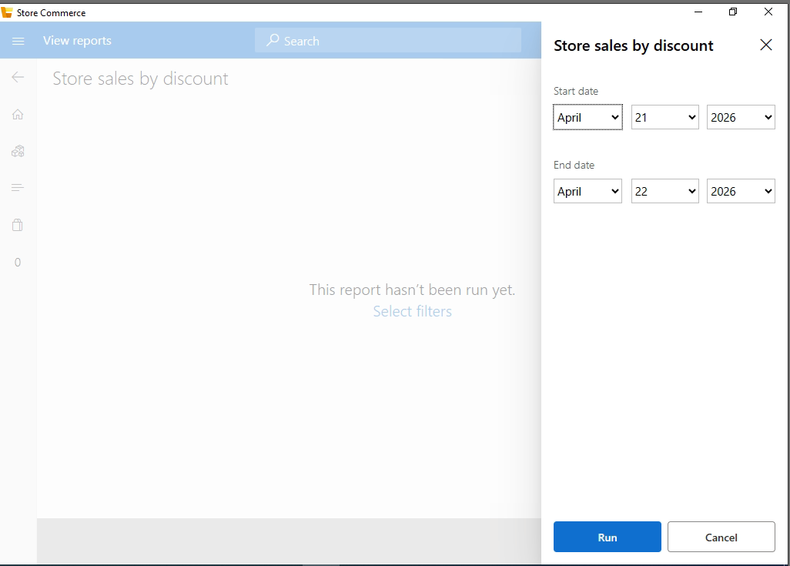

Section: Product Management
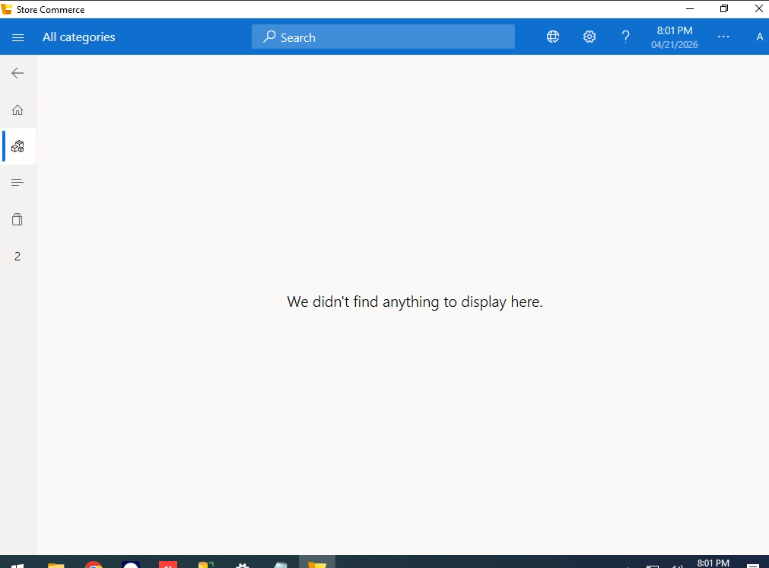
Figure: Product List View (Initial State)

Description: This section displays the list of all inventory items, including their names, SKUs, and current pricing.
Empty State Note: If no products are visible, it indicates that the local catalog needs to be synchronized or items need to be added via the back-office management system.
Functionality: Users can search for specific items using the top search bar or filter the list to manage stock availability.

Section: Category Management
The Categories module allows for the logical grouping of products to simplify the sales process.

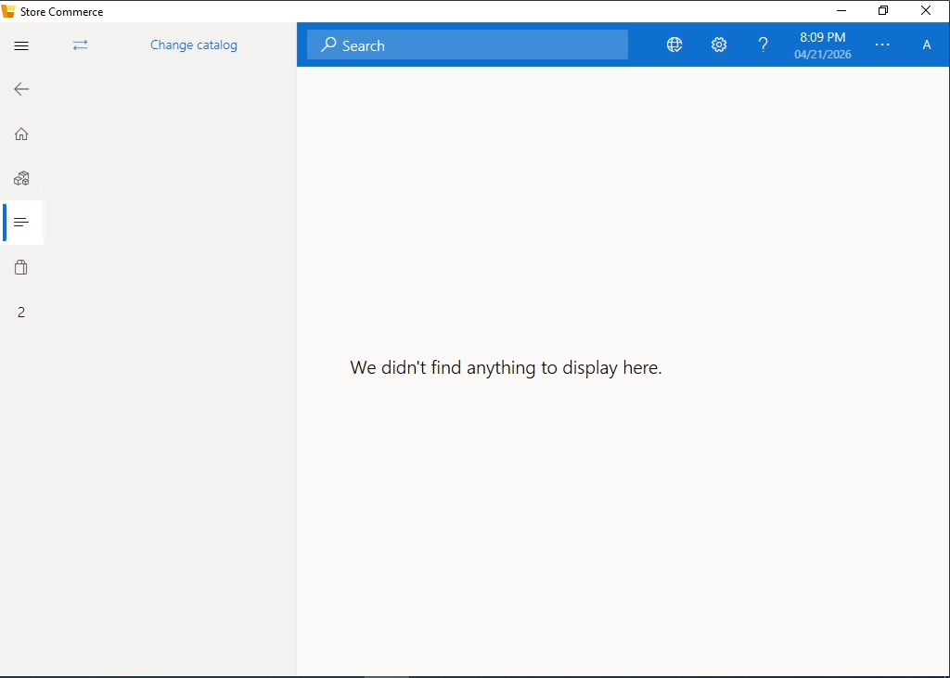
Figure: Product Categories View
Description: This view organizes items into groups such as Groceries, Electronics, or Apparel.
User Benefit: It enables the POS operator to quickly navigate through a large inventory by selecting a specific category rather than searching for individual items.
Operational Status: When active, this screen will display icons or tiles representing each product group for touch-screen optimization.

Section: Transaction Terminal (Sales Interface)
The Transaction screen is the primary interface for processing sales. It handles item entry, payment calculations, and transaction modifications.

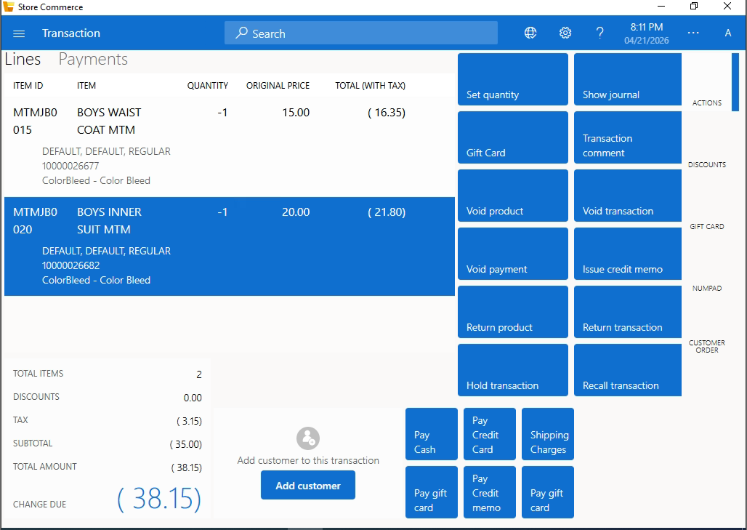
Figure: Active Sales Transaction View

Component | Visual Reference | Functional Description
Line Item Details | 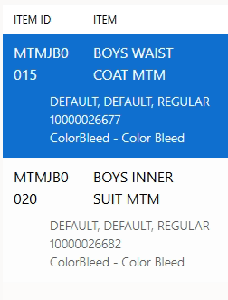 | Displays the Item ID, Description, Variant Attributes (Color, Size), and Tax Calculation. It is the primary data source for the current sale.
Quantity & Pricing | 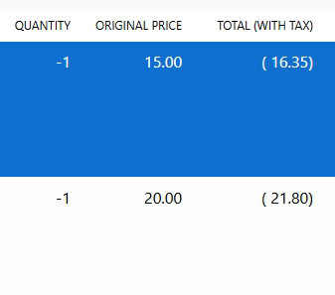 | Tracks the number of units and the original unit price. Any quantity change must trigger an immediate recalculation of the Total (With Tax).

2. Transaction Action Buttons (Right Panel)
These buttons represent the core logic of the POS system.

A. Inventory & Item Controls
- Set Quantity
  - Visual:
  - 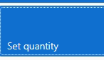
  - 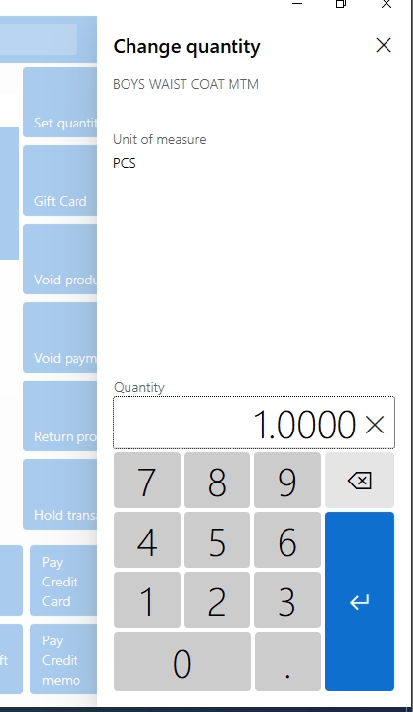
  - Description: Opens a numeric keypad to modify the quantity of the selected line item.

- Void Product
  - Visual:
  - 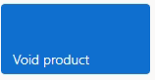
  - 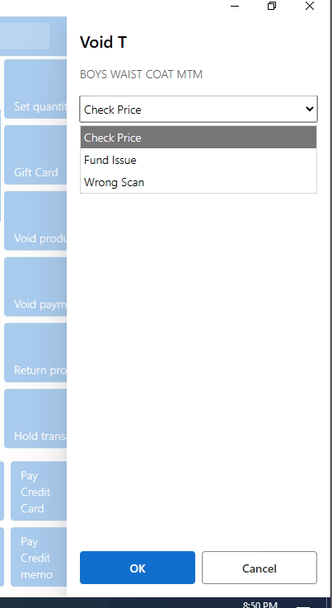
  - Description: Permanently removes the selected item from the active transaction.

- Void Transaction
  - Visual:
  - 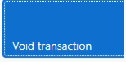
  - 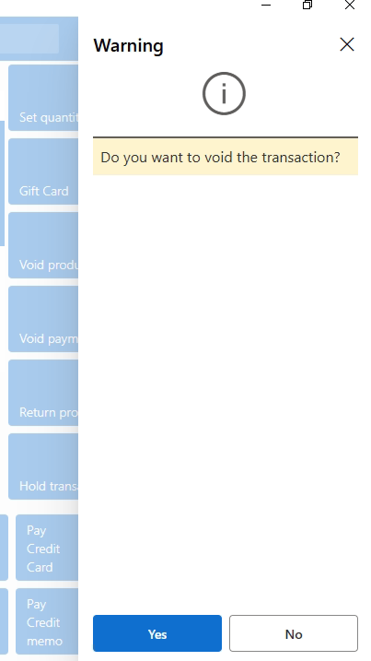
  - Description: Cancels the entire current session and clears the screen.

B. Returns & Credits
- Return Product / Transaction
  - Visual:
  - 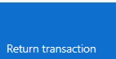
  - 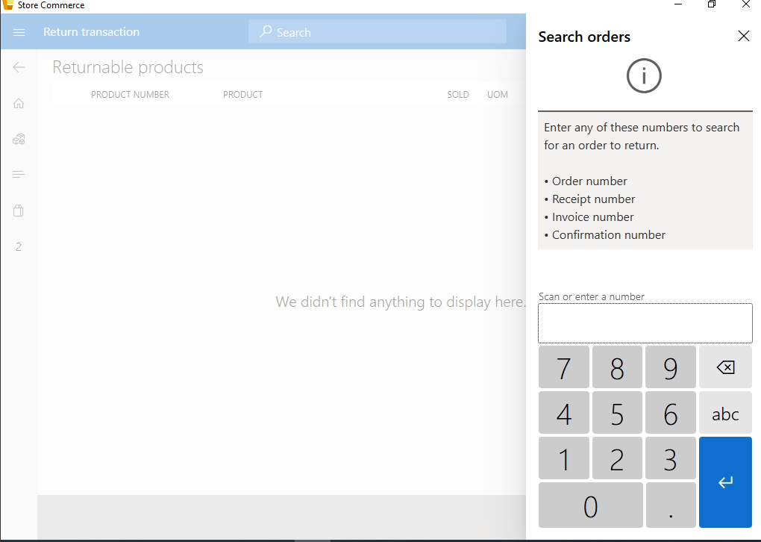
  - 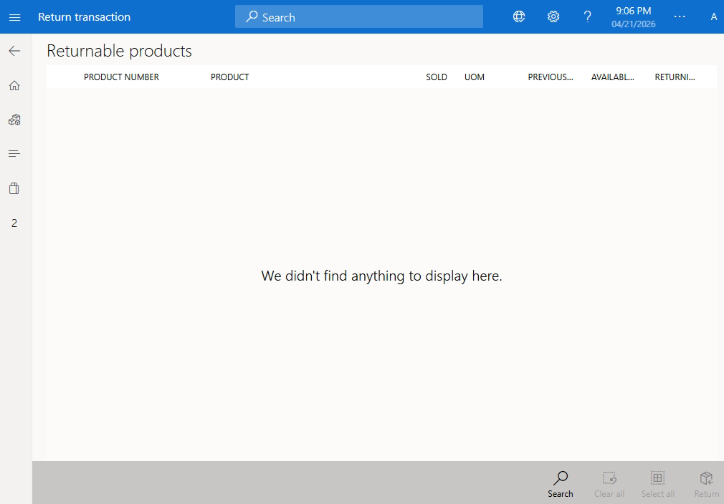
  - Description: Initiates a refund process. 'Return Product' reverses a specific line, while 'Return Transaction' reverses a previously completed bill.

- Issue Credit Memo
  - Visual:
  - 
  - 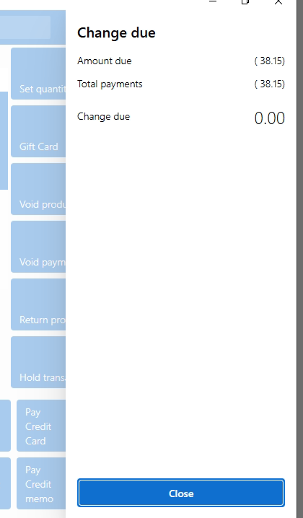
  - Description: Generates a store credit voucher instead of a cash refund. This credit can be used as a payment method for future purchases.
C. Session Management
- Hold Transaction
  - Visual:
  - 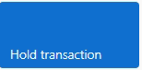

  - Description: Suspends the current transaction and saves it to the database with a "Pending" status, allowing the cashier to serve another customer.
- Recall Transaction
  - Visual:
  - 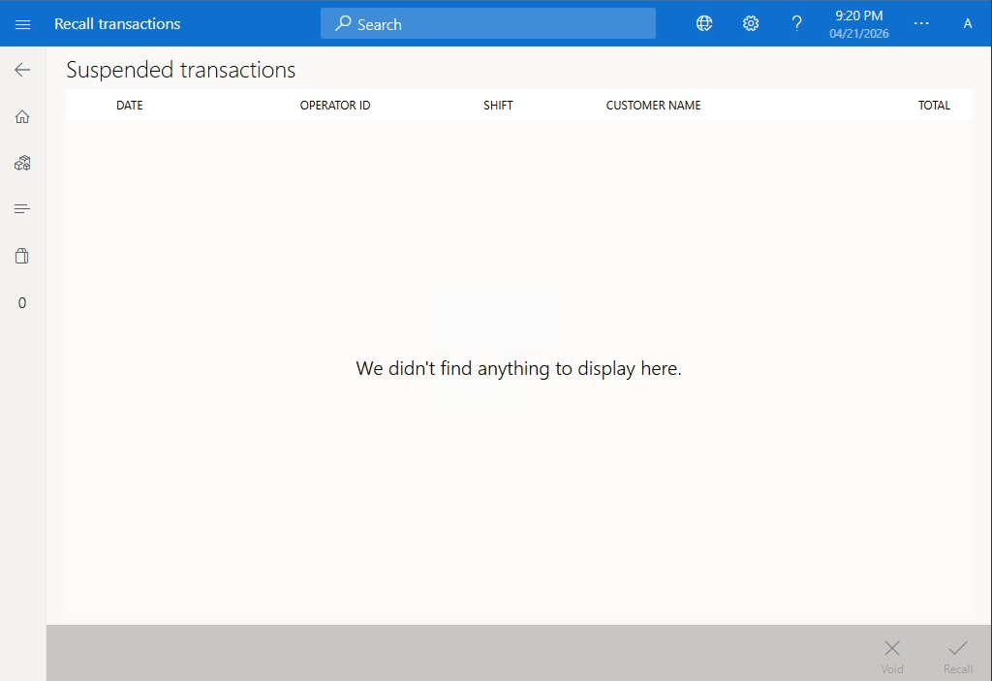
  - Description: Retrieves a list of suspended/held transactions to resume the checkout process.

Show Journal
- Visual: 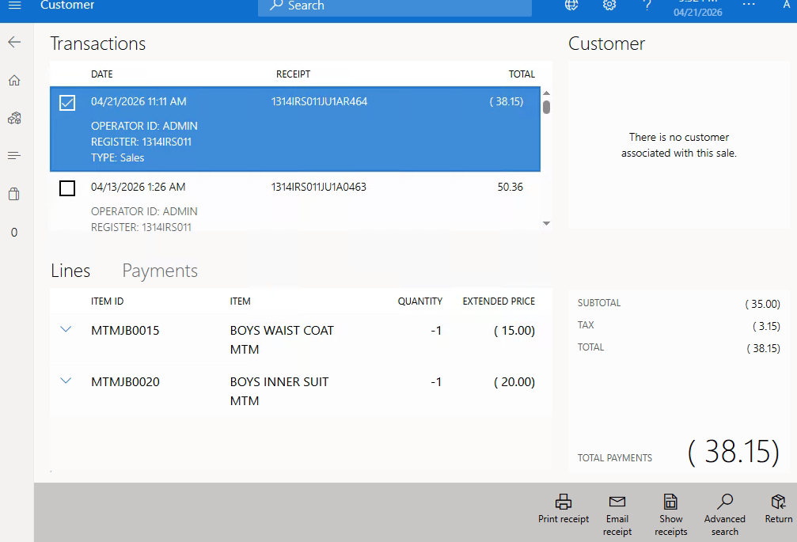
- Description: This function opens a historical log of all previous transactions processed on this terminal. It allows the operator to view, reprint receipts, or audit past sales.

Transaction Comment
- Visual:
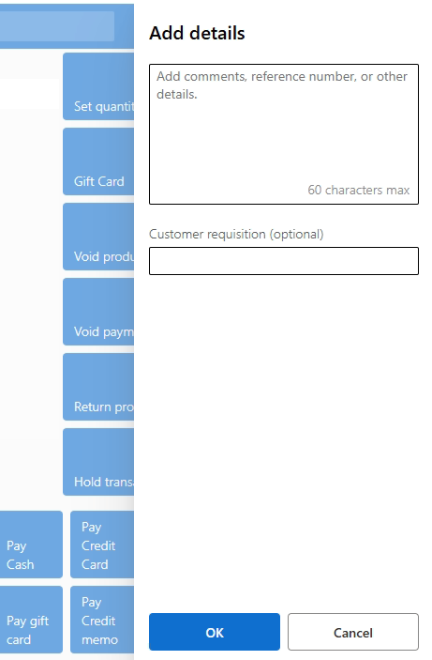
- Description: Enables the cashier to attach a text-based note or remark to the current bill. This is useful for special instructions, delivery notes, or recording specific customer requests.

Gift Card
- Visual:
- 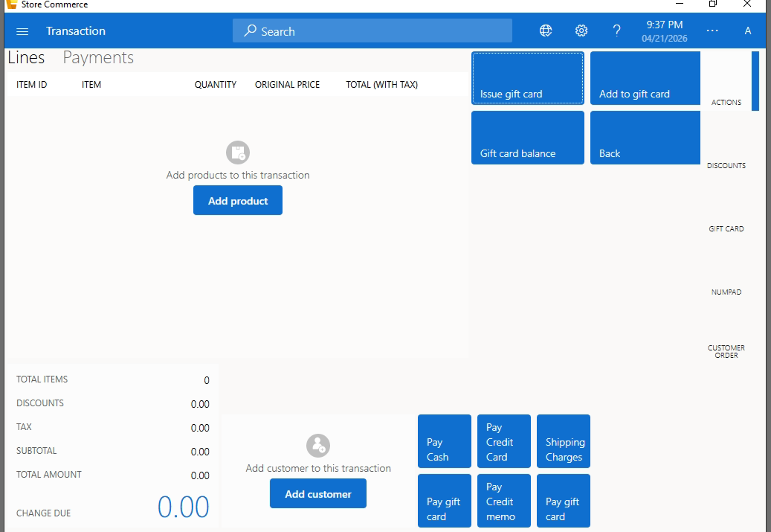
- 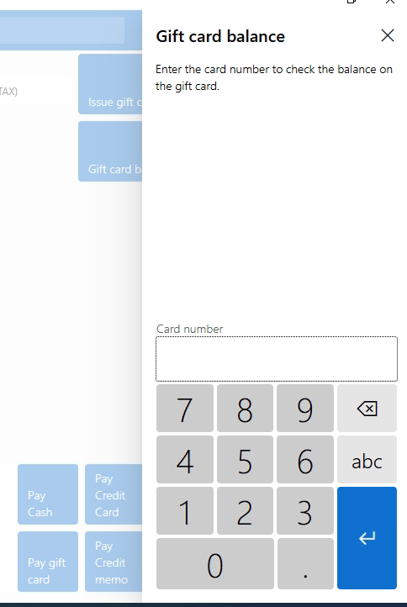
- Description: This is used to manage gift card operations, such as checking a card's remaining balance or activating a new gift card for a customer.
Void Payment
- Visual:
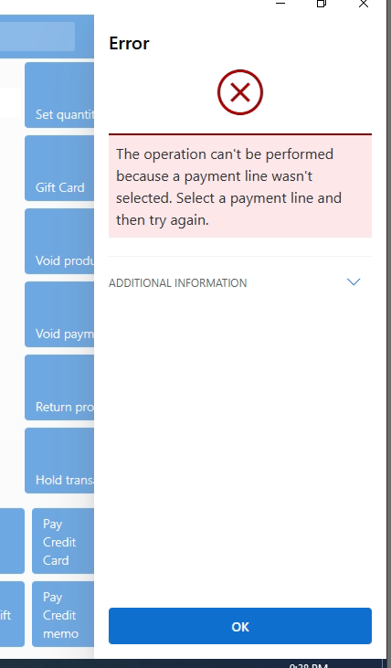
- Description: If a payment was processed incorrectly (e.g., the wrong amount was entered on the card machine), this button cancels the payment entry without voiding the items in the cart.

Checkout Operations & Financial Settlement
This module handles the finalization of the retail cycle. It integrates the financial audit trail with customer identification and multi-channel payment processing.
- Core Financial Analytics (Left Panel)

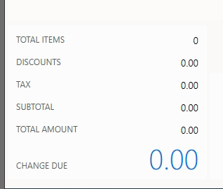
The settlement area provides a dynamic, real-time breakdown of the current transaction's fiscal value.
- Total Items: A cumulative integer count of all validated product units in the active basket.
- Discounts: Represents the total value of all price adjustments applied, including promotional codes, manual line discounts, and global header-level markdowns.
- Tax: Real-time calculation of value-added tax (VAT) or sales tax based on the store's regional fiscal rules.
- Subtotal: The net financial value of the transaction post-discount but prior to tax application.
- Total Amount: The gross payable amount. This is the primary trigger for the payment authorization protocols.
- Change Due: A calculation field that activates upon cash entry: (Tendered Amount - Gross Total). This ensures accuracy in physical cash handling.

2. Customer Relationship Management (CRM Integration)
The center panel focuses on data acquisition for marketing and loyalty purposes.
- Feature: Add Customer
- 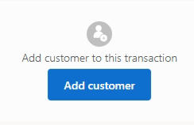
  - Functional Goal: To link the transaction unique ID (GUID) to a specific Customer Profile.
  - Technical Workflow: Triggers a modal to either search the existing database via Phone/Email or register a new entity.
  - Business Impact: Enables personalized pricing, tracking of purchase history, and accumulation of loyalty points.

Payment Gateway
These controls represent the integration points with various financial institutions and internal credit systems.

Payment Method | Functional Category | Technical Description
Pay Cash | Liquid Asset | Finalizes the sale, logs the cash drawer opening event, and generates the fiscal receipt.
Pay Credit Card | Electronic Settlement | Initiates a secure handshake with the external EFT (Electronic Funds Transfer) terminal for card authorization.
Pay Gift Card | Internal Liability | Validates and deducts from a unique pre-paid card balance. Requires real-time balance verification.
Pay Credit Memo | Store Credit | Reclaims value from a previously issued return voucher or customer credit balance.
Shipping Charges | Service Logistics | A manual or zone-based input for delivery fees. This adds a non-inventory revenue line to the transaction.

